Group music

E-PROJECT - 2025

SEMESTER-1 CPISM

CURRICULUM -7062

|  |  |  |
| --- | --- | --- |
| **F**aculty | Miss Urooj Rehman | |
| Batch | 2406C2 | |
| Serial No. | **Enrollment Number** | **Student Name** |
| 1. | Student 1581509 | Syed hassan Ali |
| 2. | Student 1580794 | Ayaan kashif |
| 3. | Student 1567683 | MUHAMMAD RAZA SARDAR |

**HOME PAGE:**

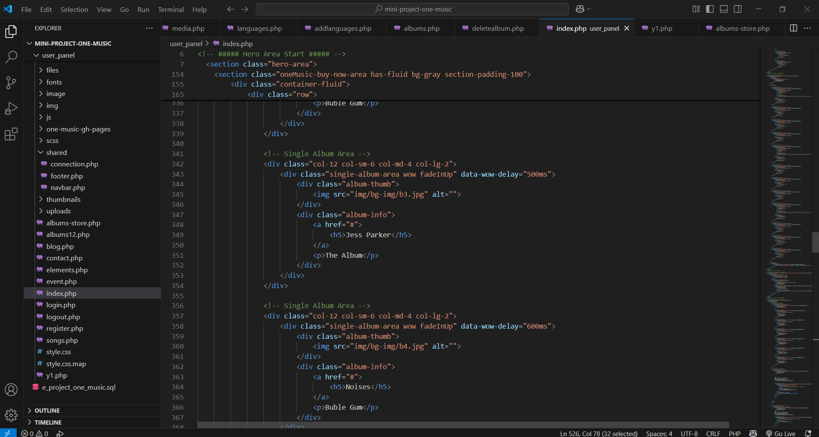

**album PAGE:**

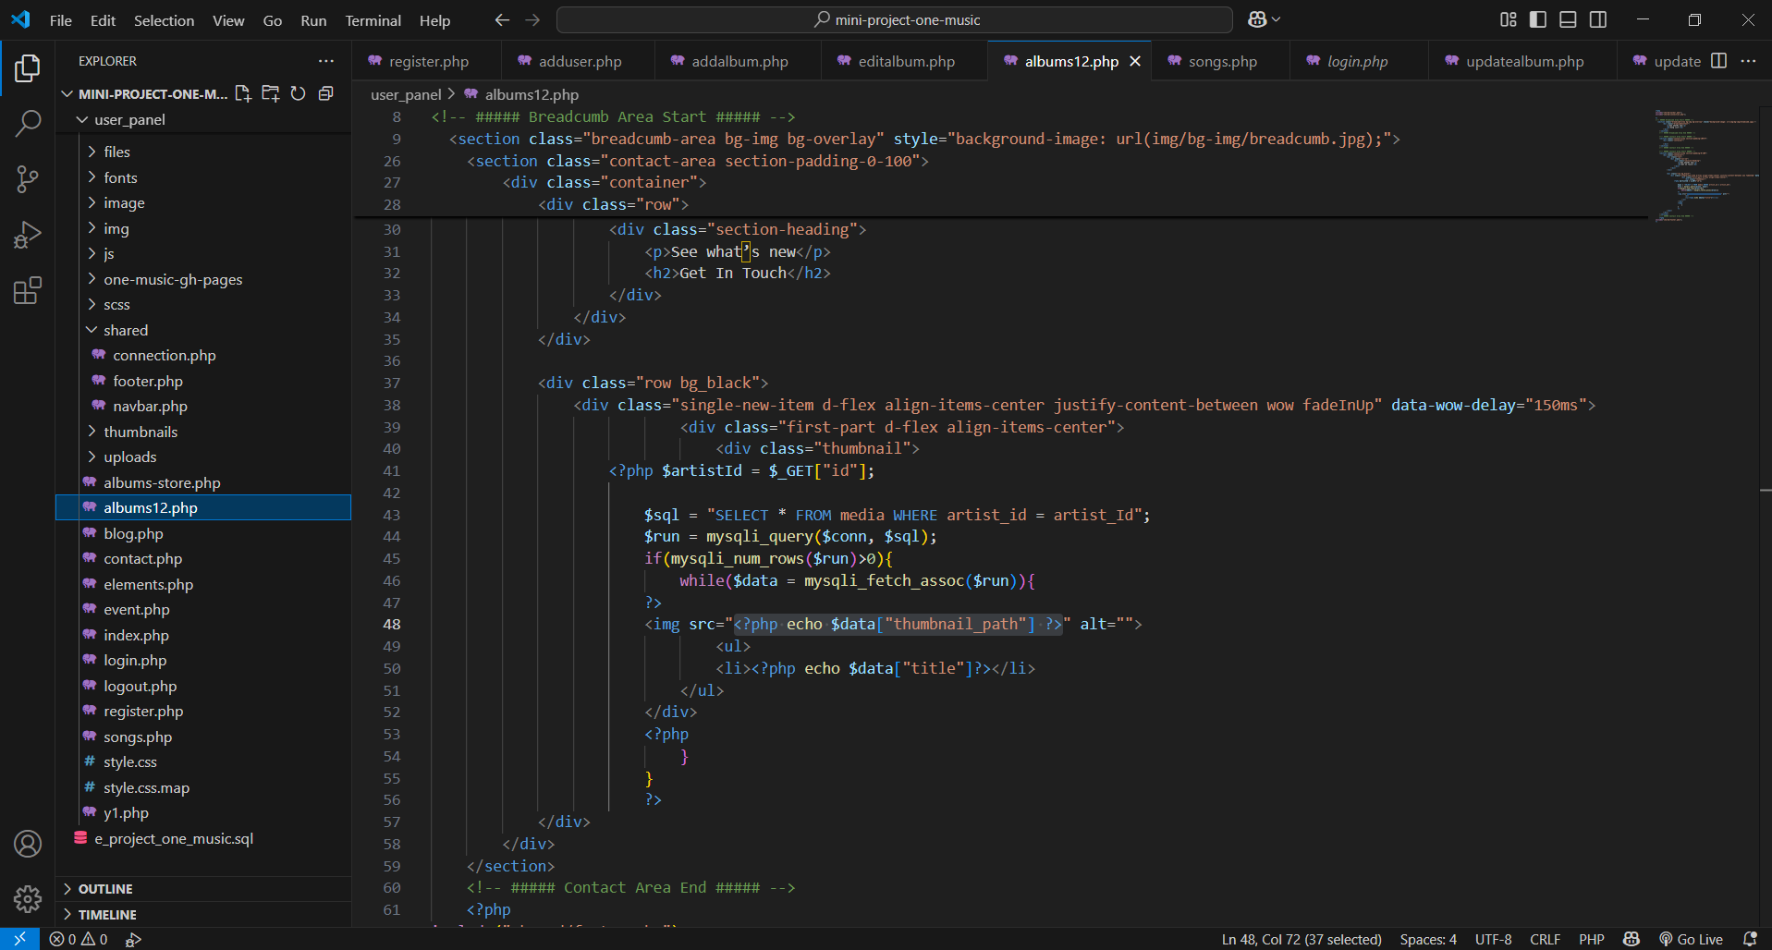

**login:**

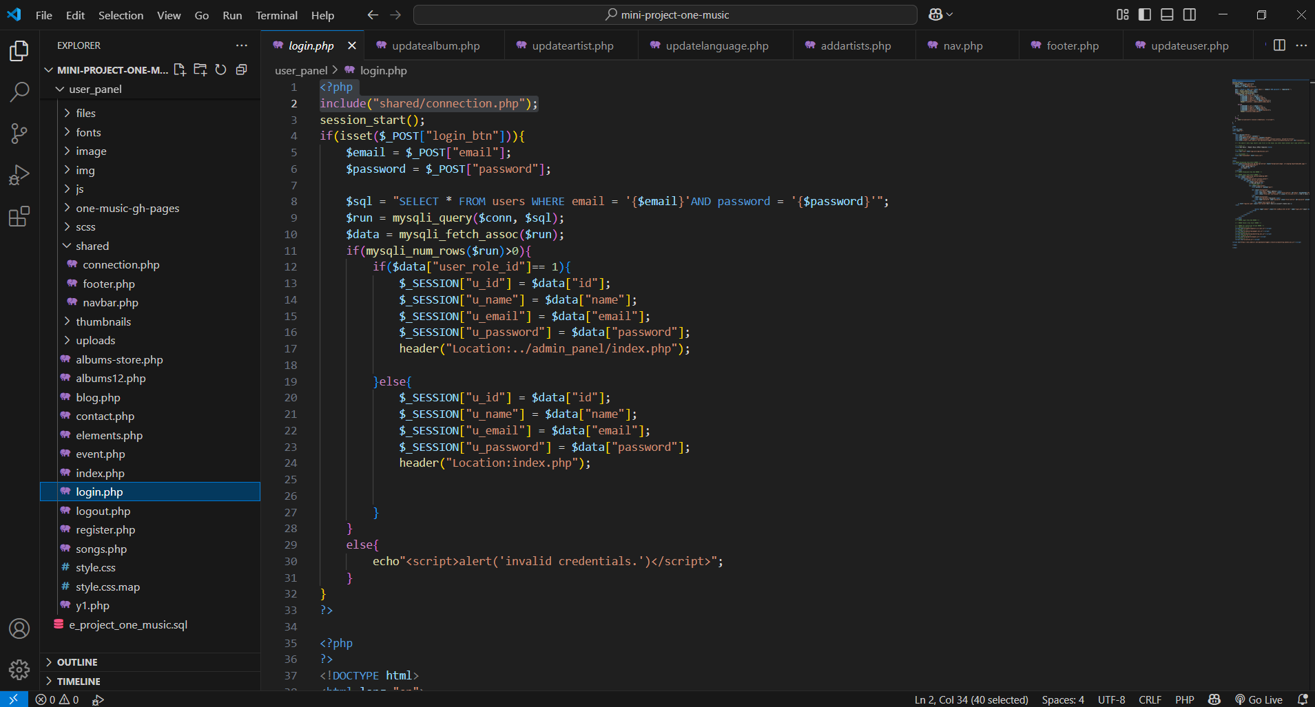

**register**

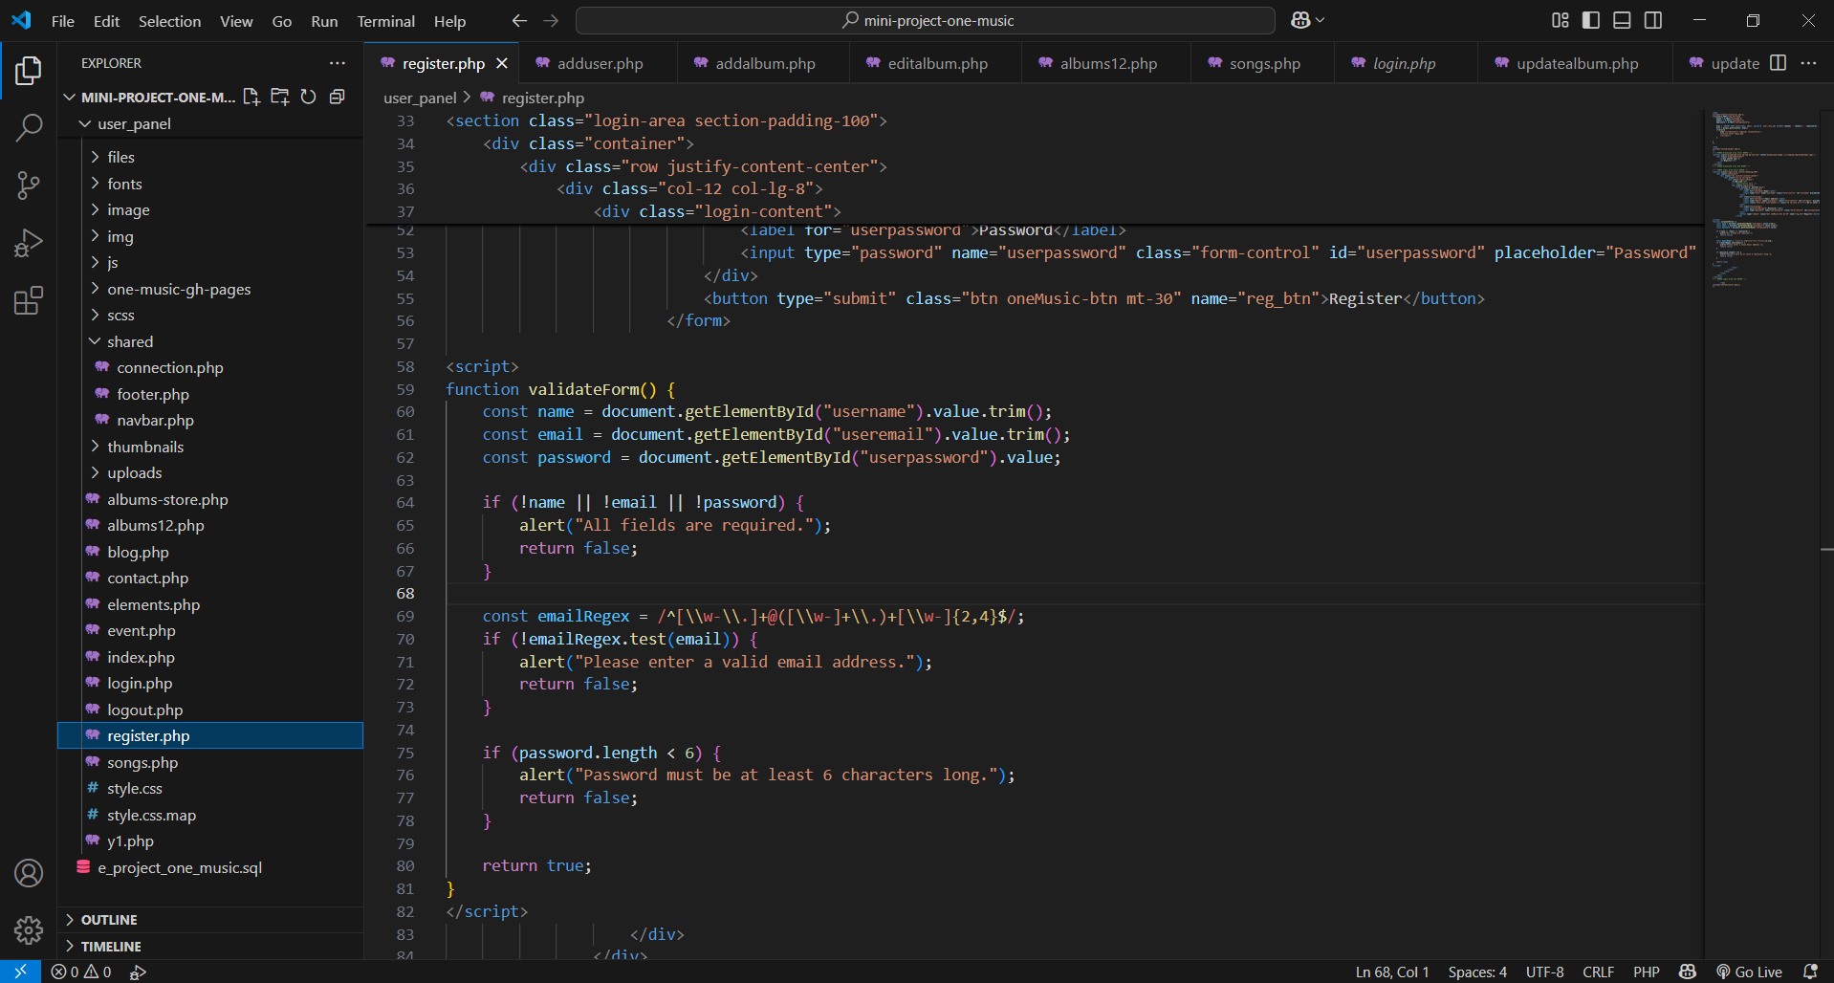

**Languages/admin_panel**

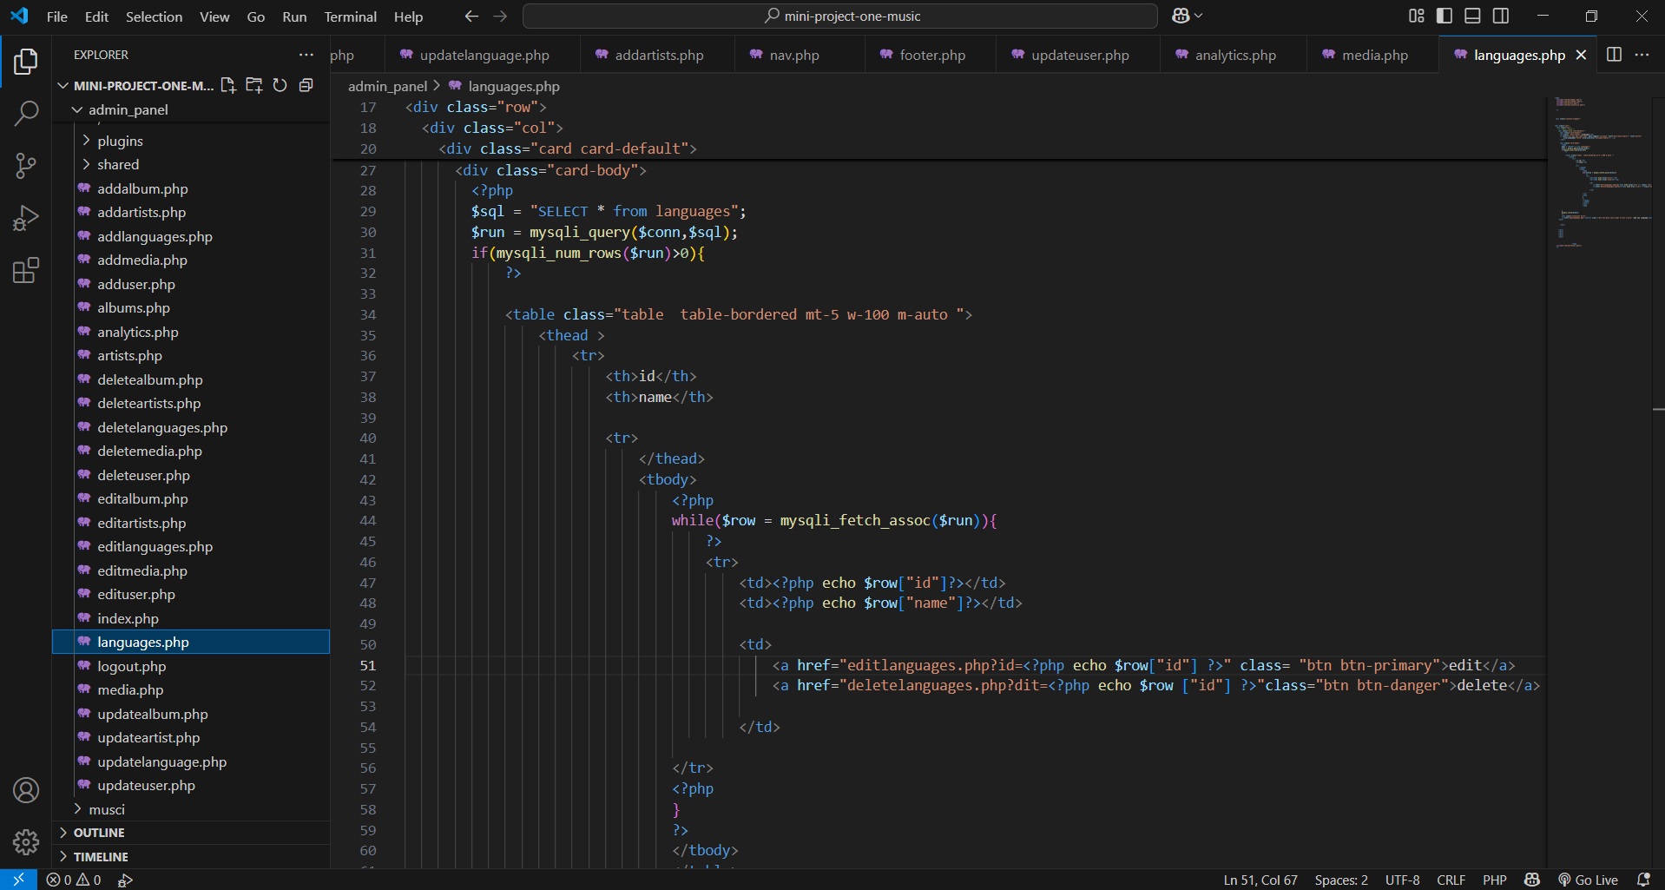

**Media/admin panel**

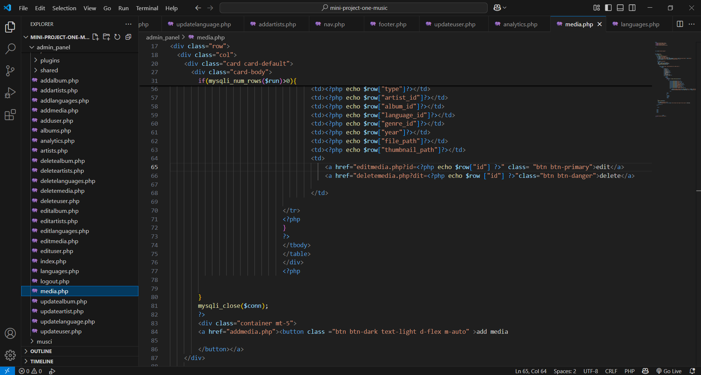

**User admin panel:**

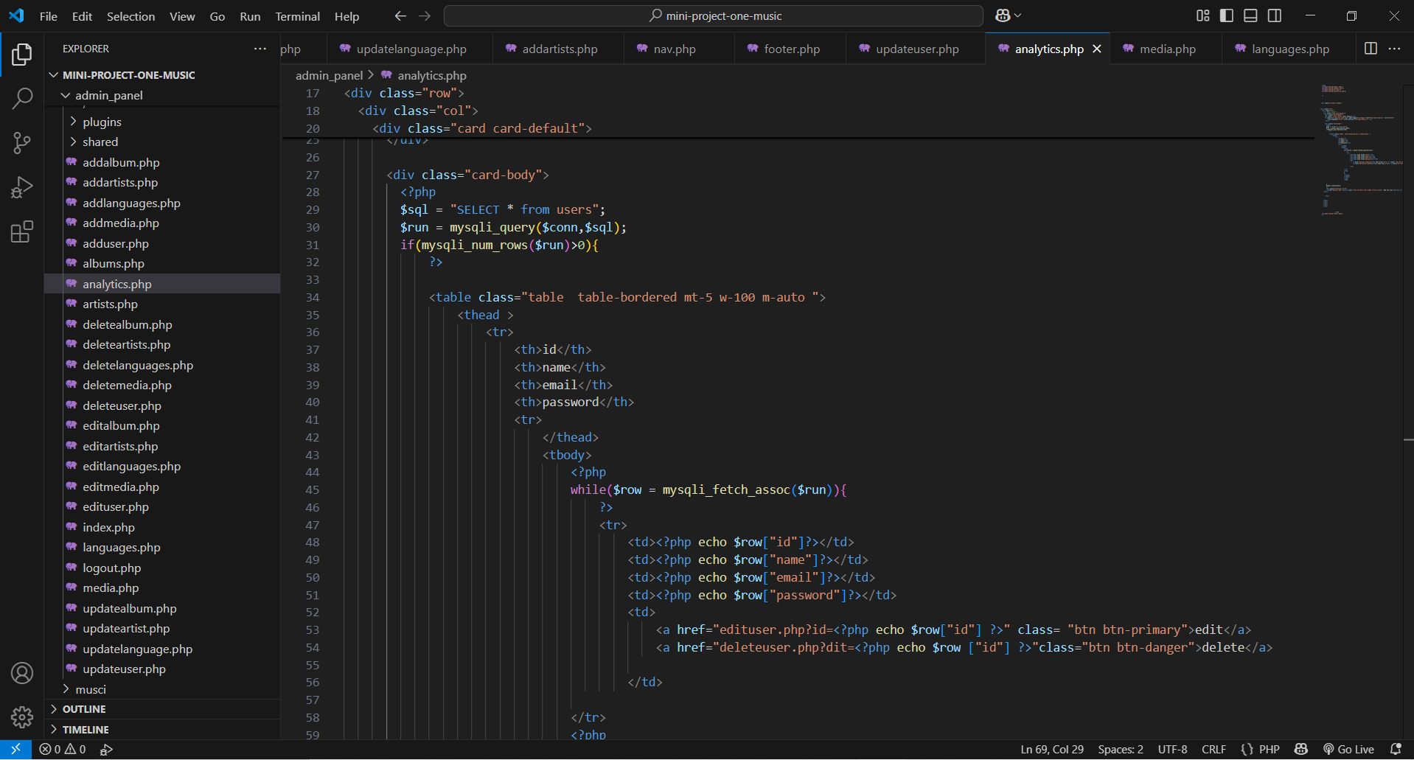

**Add. admin panel**

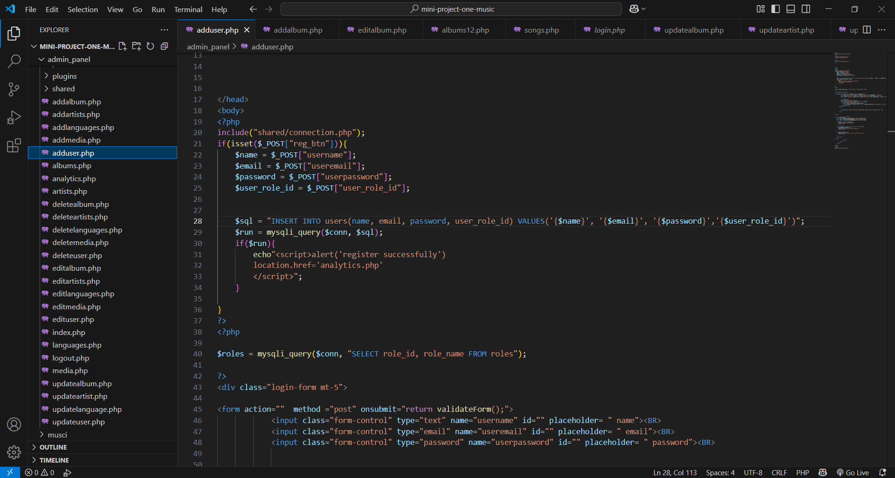

**Artist admin panel:**

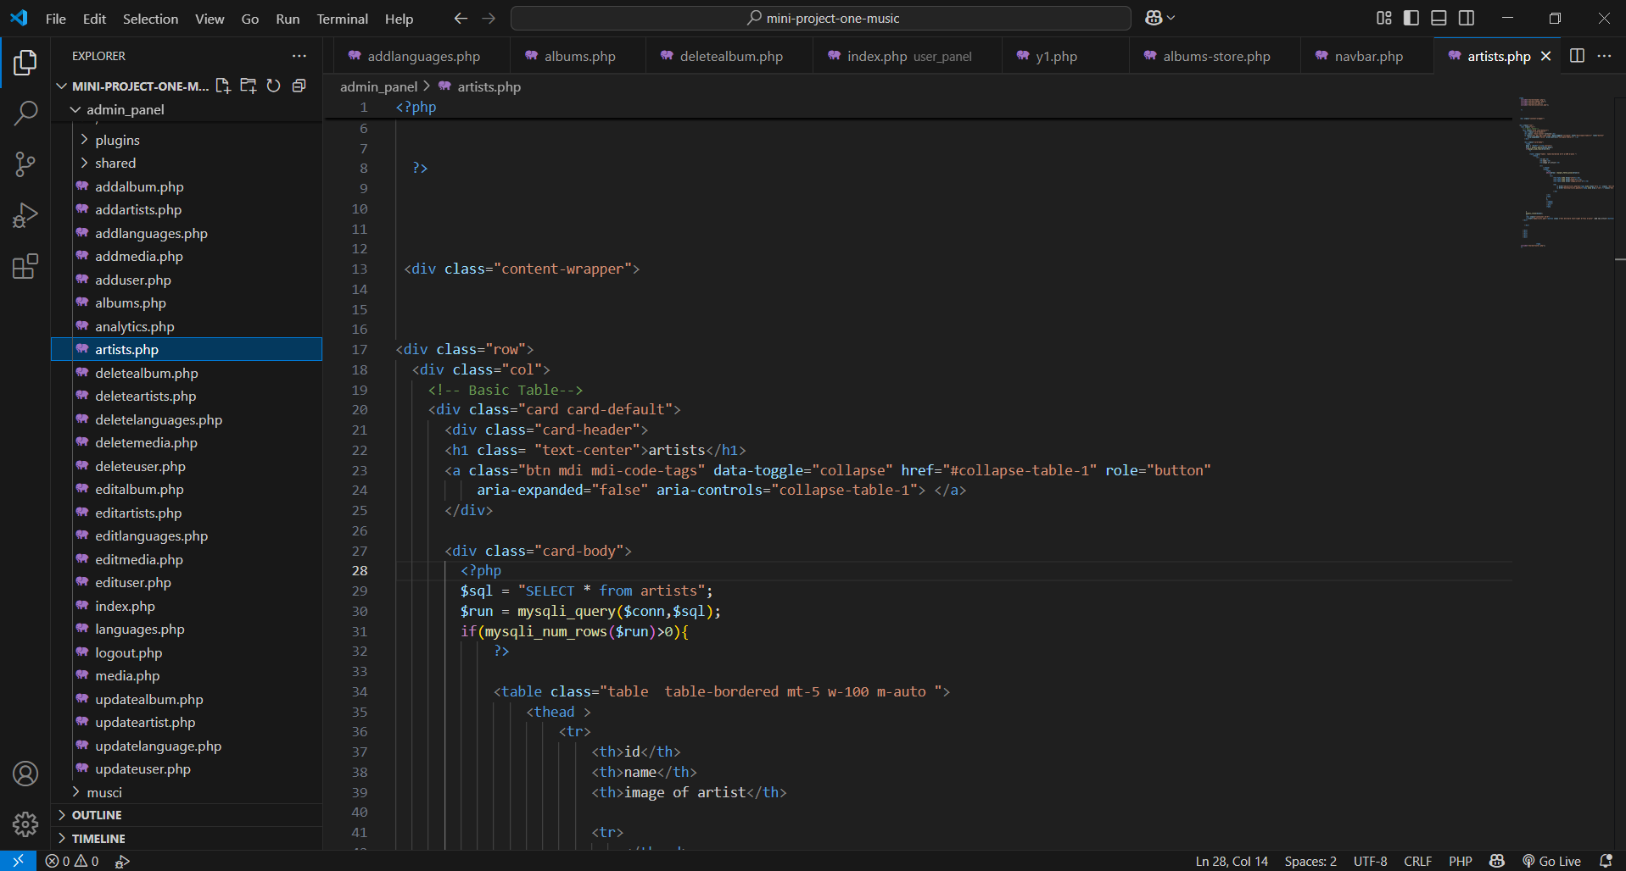

**Delete admin panel:**

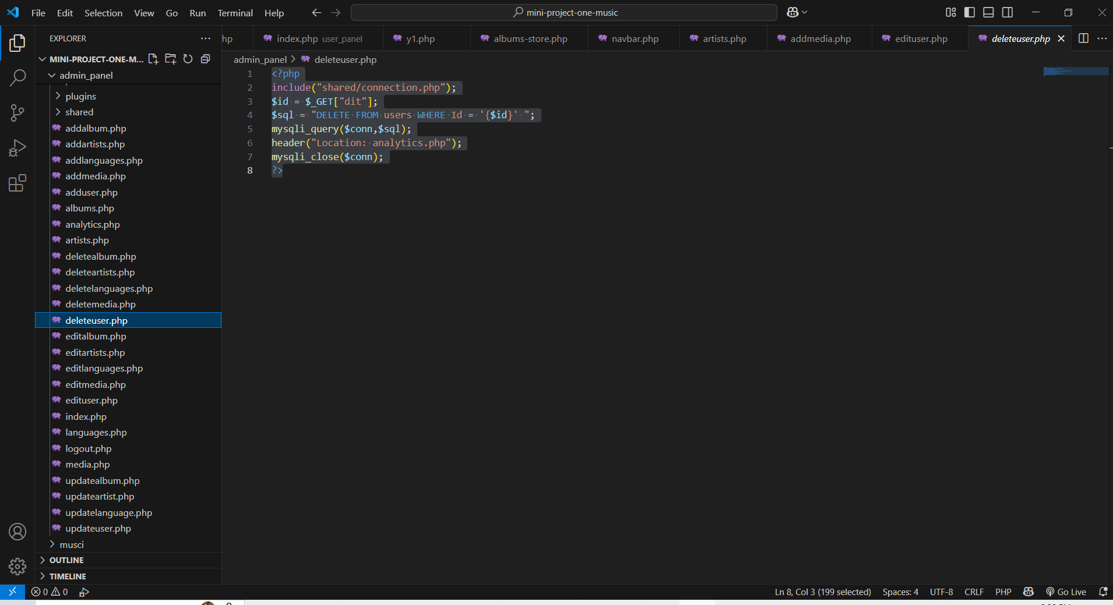

**Edit admin panel:**

